INTERPERSONAL STYLES: THE SPIRO INSTRUMENT

**Udai Pareek**

A person influences (or at least attempts to influence) other persons with whom he or she interacts. In some roles, e.g., managerial and helping roles, influence is a central function. One of the main functions of a manager is to influence others for the achievement of work objectives. Another managerial function is to help one’s subordinates to develop. Even more directly involved in influencing others are teachers, trainers, consultants, and counselors. The process of helping someone to learn and change is essentially the process of influencing the individual’s ideas, values, attitudes, and behavior.

Those in influencing roles not only solve problems and help others but they also have an impact on others’ ability to solve future problems. They can develop others or they can make them dependent, limiting their autonomy. Their habitual ways of interacting with their employees, participants, trainees, or clients can be called their interpersonal styles.

THE FRAMEWORK FOR UNDERSTANDING STYLES

A useful conceptual framework to describe an individual’s style is transactional analysis (TA). Transactional analysis concepts are quite popular, and two basic concepts can be used to understand influence styles: the ego states and the existential positions.

Each person involved in transactions with others has three ego states:

1. *The Parent* regulates behavior (through prescriptions and sanctions) and nurtures (by providing support).

2. *The Adult* collects information and processes it.

3. *The Child* has several functions primarily concerned with (a) creativity, curiosity, and fun; (b) reactions to others (including rebellion); and (c) adjusting to others’ demands or sulking.

Each ego state is important. However, the functional or dysfunctional roles of these ego states depend on the general existential or life position a person takes. Harris (1969) has conceptualized four primary existential or life positions: I’m OK, you’re OK; I’m not OK, you’re OK; I’m OK, you’re not OK; and I’m not OK, you’re not OK.

James (1975) has suggested that, in general, the concepts of OK and not OK can be used to understand how bosses behave. Avary (1980) has similarly proposed OK and not-OK dimensions of the six ego states. Savorgnan (1979) has discussed the OK and not-OK dimensions of the two Parent ego states. Figure l shows the four life positions in terms of interaction styles.

The four general interaction styles can be elaborated by combining them with the ego states. Two dimensions of the Parent ego state (critical or regulating and nurturing), three of the Child ego state (adaptive, reactive, and free or creative), and the Adult ego state are used. All three ego states and the subego states are important and perform distinct functions. Each ego state meets a basic need. Avary (1980) has proposed that six basic needs are met by the six ego states, which can be OK or not OK. These are:

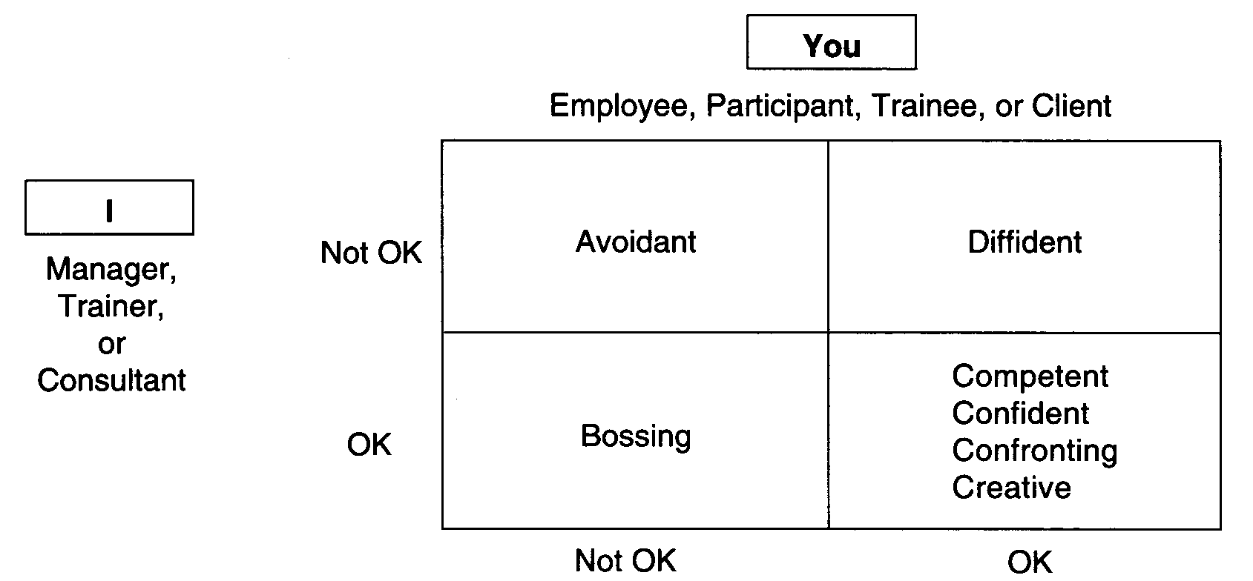

Figure 1. General Interaction Styles in Four Life Positions

1. The need to express love and care, manifesting as Nurturing Parent (OK) Or Rescuing Parent (not OK);

2. The need for power, faith, and self-confidence as Firm Parent (OK) or Critical Parent (not OK);

3. The need to think and evaluate information as an Adult (OK) or any not-OK ego state;

4. The biological needs and the need to feel and experience stimulation as a Natural Child (OK) or a Persona (not OK);

5. The need to be creative or intuitive as a “Little Professor” (OK) or a Rebellious or Defensive Child (not OK);

6. The need for approval and safety as an OK-Adapted Child (OK) or a Helpless Child (not OK).

The interpersonal style of an individual depends on the person’s combination of the six ego states with the life positions. Combining the six ego states with the four life positions, we obtain twenty-four influence styles, as shown in Table 1.

| Table 1. Elaborated Interpersonal Styles | | | | | |
| --- | --- | --- | --- | --- | --- |
|  |  | Life Positions | | | |
| Ego States | Basic Need | I’m Not OK, You’re Not OK | I’m OK, You’re Not OK | I’m OK, You’re OK | I’m Not OK, You’re OK |
| Regulating | Love, Care | Traditional | Prescriptive | Normative | Indifferent |
| Parent |  |  |  |  |  |
| Nurturing | Power | Over-indulgent | Rescuing | Supportive | Ingratiating |
| Adult | Rationality | Cynical | Task Obsessive | Problem Solving | Overwhelming |
| Adaptive | Approval, Safety | Sulking | Complaining | Resilient | Dependent |
| Child Reactive | Aggression | Withdrawn | Aggressive | Confronting | Intropunitive |
| Creative | Creativity | Humorous | Bohemian | Innovative | Satirical |

STYLES PROFILE

The twenty-four styles shown in Table 1 may be too extensive for some situations. As James (1975) and Avary (1980) have suggested, two dimensions (OK and not OK) can be combined with the various life positions. Combining the six ego states (two Parent, one Adult, and three Child) with the two life positions (OK and not OK), we obtain twelve styles. These are shown in Table 2.

| Table 2: Twelve Influence Styles | | |
| --- | --- | --- |
|  | Styles in Two Life Positions | |
| Ego States | Not OK | OK |
| Nurturing Parent | Rescuing | Supportive |
| Regulating Parent | Prescriptive | Normative |
| Adult | Task Obsessive | Problem Solving |
| Creative Child | Bohemian | Innovative |
| Reactive Child | Aggressive | Confronting |
| Adaptive Child | Sulking | Resilient |

*Rescuing Style:* Such a style indicates a dependency relationship in which the manager, trainer, or consultant perceives his or her main role as that of rescuing the subordinate, participant, trainee, or client, who is seen as being incapable of taking care of himself or herself. Another characteristic of this style is that support is provided conditionally, contingent on deference to the provider. The general attitude is one of superiority; the person’s support constantly reminds others of their dependence. Obviously, this style does not help other people to become independent and to act   
by themselves.

*Supportive Style:* In this style, support is provided when needed. James (1975) uses the term “supportive coaches” for managers with this style. They encourage their subordinates and provide the necessary conditions for continuous improvement. Consultants in this style show patience in learning about the problems of their clients and have empathy with them.

*Prescriptive Style:* People with this style are critical of the behavior of others and develop rules and regulations and impose them on others. Managers using this style make quick judgments and insist that certain norms be followed by all their subordinates. A consultant may give advice and prescribe solutions for clients rather than helping the clients to work out alternative solutions for their problems.

*Normative Style:* These managers are interested in developing proper norms of behavior for their subordinates but also in helping the subordinates to understand why some norms are more important than others. A consultant with this style not only helps clients to solve a specific problem but also helps them to develop ways of approaching a problem and raises questions about relevant values. Such a consultant emphasizes the development of a general approach to the problem. Trainers with this style influence the participants through modeling behavior. They also raise questions about the appropriateness of some aspects of behavior and work.

*Task-Obsessive Style:* People with this style are most concerned with the task. Matters not directly related to the task are ignored. They are not concerned with feelings and, in fact, fail to recognize them, as they do not perceive them as related to the task. They attempt to function like computers. A task-obsessive trainer is insensitive to the emotional needs, personal problems, and apprehensions of the participants.

*Problem-Solving Style:* In this style, a manager is concerned with solving problems but does not see the problems as being merely confined to the task. For such persons, the problems have various dimensions. The focus of the manager, consultant, or trainer is on dealing with and finding out solutions to problems. In this process they solicit the help of and involve subordinates, clients, trainees, and participants.

*Bohemian Style:* The creative child is active in this style. The person has lots of ideas and is impatient with current practices. The person is less concerned with how the new ideas work than with the ideas themselves. Such people are nonconformists and enjoy experimenting with new approaches, primarily for fun. They rarely allow one idea or practice to stabilize before going on to another.

*Innovative Style:* People with this style have enthusiasm about new ideas and new approaches and take others along with them. However, they pay enough attention to nurturing an idea so that it results in concrete action and becomes internalized in the system. Such people are innovators.

*Aggressive Style:* People with this style are fighters. They show their aggression toward others. They may fight for their subordinates, clients, or participants, or for their ideas and suggestions, hoping that this will help them to achieve their desired results. Their aggressiveness, however, makes people avoid them and not take them seriously.

*Confronting Style:* In this style, the person is concerned with the exploration of a problem. Perseverance is a main characteristic. They confront the organization to get things done for their subordinates or clients. They are more concerned with confronting problems than with confronting other persons for the sake of confrontation. A consultant with this style may also confront the client in order to help the client to openly explore various dimensions. Such people are frank and open but are equally perceptive and sensitive. They respect the feelings of others.

*Sulking Style:* People with this style keep their negative feelings to themselves, find it difficult to share them, and avoid meeting people if they have not been able to fulfill their part of the contract. Instead of confronting problems, a person in this style avoids them and feels bad about the situation but does not express these feelings openly.

*Resilient Style:* In this style, persons show creative adaptability-learning from others, accepting others’ ideas, and changing their approaches when change is needed.

Persons in influence roles (managers, consultants, counselors, or trainers) may show several of the behaviors described in this article. Each person, however, uses one style more frequently than others.

Predict for yourself.